

**Manual**

**Direction 01**

**To the user 02**

**Safety sign 03**

**Product structure 04**

**Technical parameters 05**

**Electromagnetic interference information 06**

**Safety guidelines 06**

**User** 06

**Caregiver**  07

**Matters need attention of joystick** 07

**Matters need attention when the Air Hawk in stationary state** 08

**Using environment**  08

**Suitable road**  08

**Road driving**  09

**The motorized vehicle**  09

**Balance of driving**  09

**Attention on/off the Air Hawk**  10

**Attention on hand stretch out and body tilt** 10

**Attention on dressing in the Air Hawk** 11

**Through the obstacles**  11

**Driving back**  11

**Cant/slope/slope** 11

**Weight limit** 12

**Matters needing attention when up and down the stairs** 12

**Installation instruction 13**

Safety belt installation  13

Joystick installation instruction 13

**Control guidance 14**

Control panel 14

Use the joystick to drive Air Hawk 15

The use of the horn 16

**Brake instruction 17**

**The battery instruction 18**

Install/disassemble the battery 19

Battery charging 19

Over discharge protection device 19

Over-current protection device 19

Clean the battery socket 19

**Unfold and fold** 21

Air Hawk folding method 23

Unfold the Air Hawk 23

**Faults and elimination method 23**

**Guarantee specification 24**

**Accessories 26**

Direction

**The Air Hawk is powered by two 24 volt DC motor’s, which can be used indoor’s and outdoor’s. Designed to transport individuals with a disability and the elderly. The Air Hawk is compacted, light weight, foldable and easy to carry as well as safe & comfortable.**



**Caution**

|  |
| --- |
| **User:**  Please don’t use and operate the Air Hawk until you understand how it functions. this Air Hawk, In the event you do not understand this warning and instruction, please contact your dealer for professional technical guidance and help, operating the Air Hawk without understanding how it operates may cause danger and injury due to operating incorrectly. Be sure to read this operation manual completely prior to attempting to operate or use. |
| **Distributor and professional technical personnel:**  Please don’t use and operate the Air Hawk until you understand how it functions. this Air Hawk, In the event you do not understand this warning and instruction, please contact manufacture or distributor professional technical guidance and help, operating the Air Hawk without understanding how it operates may cause danger and injury due to operating incorrectly. Be sure to read this operation manual completely prior to attempting to operate or use. |

To the user

**Dear user:**

Thank you for purchasing your Air Hawk. , The Air Hawk was designed and manufactured by EZ-Ultra Nanjing Jin Bai Apparatus Co.

We trust your new Air Hawk will give you new freedom to travel where you want when you want.

Before operating your new Air Hawk for the first time, please read this user manual carefully. This instruction manual will help you to understand how to operate your new Air Hawk as well as the appropriate maintenance. In the event you do not understand how to operate your new Air Hawk after reading this instruction manual completely our you do not feel comfortable operating your new Air Hawk stop attempting to use or operate your new Air Hawk and contact your dealer for support and further instruction..

Safety sign

The signs below can help you identify some warning, mandatory operation and prohibitive operation of the Air Hawk.

 Identifying and understanding each symbol below is important.

Read and follow the guidance of this manual.



The safety warning sign: or a suggestion for a dangerous concerns of operation.



The second class (auxiliary) equipment



The main application or operation.



When using please don't use mobile phones, interphone, laptops or other radio

transmitters.



Easy extrusion/grinding points



Avoid the rain, snow, ice, salt, and exposure to rain and water, it should be maintained in a clean, dry condition.



The Air Hawk has passed the electromagnetic/RF resistance to 20 V/M.



The battery contains corrosive chemicals.



Explosive

 Don't use the battery with different capacity and models at the same time, don't

mix up the old and new batteries when replacing, please change it entirely.

 Keep tools and other metal objects far away from positive and negative

Ends of battery, if exposed to the both ends, it can cause a short circuit and

electric shock.

 This symbol means flammable material, do not expose to flame, spark and or heat.

 Disposal and recycling--

the right to recycle, the company manufacturer authorized will recycle and pack the

products after receiving the user's requirements.

Technical parameters

|  |  |
| --- | --- |
|  | |
| folded size | 61cm*26cm*77cm |
| unfold size | 87cm*61cm*92cm |
| max load | 140 kg |
| **motors** |  |
| type | brushless DC motor |
| rated power | 180 W |
| the input power | DC 24V |
| number | 2 |
| brake system | intelligent type electromagnetic brake |
| braking system | 1.5 m (59") at highest speed |
| **battery** |  |
| type | lithium battery |
| standard capacity | 8 Ah/16 Ah |
| output voltage | DC 24V |
| number | One or two |
| **controller** |  |
| type/plug type | assist type/European standard, 2 core |
| input power | AC 100-220 V, 50-60Hz |
| output voltage/current | DC 24V, 2A |
| **front wheels** |  |
| outer diameter/tire width | 6" × 2"(150 mm x 38 mm) |
| type | solid tire |
| material | PU |
| quantity | 2 PCS |
| **back wheels** |  |
| outer diameter/tire width | 8" × 1.96"(200 mm x 50 mm) |
| type | Solid tire |
| material | PU |
| number | 2 PCS |
| self weight | 19 kg |
| maximum grade ability | 12 |
| Running distance | 16km-32km |
| highest speed | 6 km/h (4 mph) |
| turning radius | 800 mm (31") |
|  |  |

Electromagnetic interference information

 **Caution**

Electromagnetic interference may cause the Air Hawk to move without user command, reading and understanding this is very important.

This chapter will explain the problems caused by the electromagnetic interference, in order to help the users to understand and take corresponding protective measures to avoid or minimize the risk. Some content is about the accidents involved in some particular environment or conditions.

**·Electromagnetic interference from radio waves**

Your new Air Hawk as is all power wheelchairs is susceptible to electromagnetic interference, the electromagnetic energy usually is emitted from radio, television, radio transmitters, two-way radios, and mobile devices. This electromagnetic interference may cause the brakes to become control, and move itself without the user commands through joystick, also it could cause the control system of Air Hawk permanent damage. So the ability of one product to resist electromagnetic interference is particularly important. The Air Hawk has passed the resistance strength of 20 V/m electromagnetic interference test, it has high anti-interference ability, and can resist some common radiation electromagnetic interference in the daily life.



**Caution**

**1. Although the Air Hawk is equipped with anti-interference ability, the users still should abide by the following rules when using:** when power supply is connected, do not operate the radio such as transmitter, a receiver, citizens band (CB), or turn on the personal communication devices such as mobile phone, etc.

2. Try to avoid operating near radio source, such as radio, television, etc.

3. If in the event of uncontrolled movement or stop, the user should “turn off” the power supply immediately, and then contact the manufacturer. Do not change any parts of this Air Hawk, including increase or decrease any accessories, in case of reducing its anti-jamming ability.

Safety guidelines

**user**



**Caution**

Before using this Air Hawk, you should keep tools and other metal objects from the positive or negative of the battery, if exposed to both ends, it will cause a short circuit and electric shock.

1. Health care workers should have training and professional guidance of using.

2. Before you use the Air Hawk, you should understand its operation first.

3. You should practice some operations with the help of nursing staff, such as turning, surmounting obstacles, brake, until you are independent and skilled in performing these operations.

4. Please Do Not attempt to use the Air Hawk without fully understanding how it operates.

5. Know the area that you will travel or drive, check whether there is danger or not, and master the method to avoid these risks.



**Caregiver**

**Caution**

1. You need to cooperate with user, and listen to the opinions of user’s doctors, nurses, or physical therapists to determine whether or not user is capable of operating this device.

2. In the event you wish to push the Air Hawk manually you must disengage the electromagnetic brakes with leaver located on each rear wheel.

3. When pushing the Air Hawk manually, you must use the push handle in the back of the backrest. It can provide a safe and reliable force point to prevent damage or danger.

4. Check the push handle to ensure the push handle cannot rotate or slide when the user is going through the obstacles.

4.1 To prevent injuring the user’s back, you should ensure the user is in correct status which is accorded with human body dynamics. When you lift or support the user do not tilt Air Hawk, you should bend your knees and keep your back vertical.

4.2 Before attempting to lift or transfer a user please explain to user what you intended to do, and explain the reasons, and explain to the user what you want him to do at the same time. This will allow the user to prepare for what you are about to do and reduce the risk of accidental injury.

**Joystick Operation**

 **Caution**

Caution: You may need to adjust the Air Hawk controller Settings (pictured below), in order to reduce the risk of injury to user or others.

1.Check and adjust the Settings every six months. (if necessary, check and adjust more frequently)

2. If you find any setting that have changed the function of the Air Hawk, please contact the supplier.

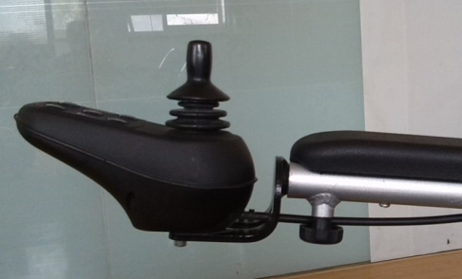

**Using The Air Hawk**



**Caution**

1. When Air Hawk stops, even in a short period time, please ensure that the power is off (correctly). This will prevent:

• You or others from mistakenly touching the joystick causing unexpected movement.

• Affected by the unexpected source of electromagnetic interference, which will influence the normal use of Air Hawk

**Operating environment**

**Caution**

This Air Hawk must not be used in heavy rain, snow or ice conditions.

1. Contact with water or excessive moisture can cause electrical failure. Frame, motor and other Air Hawk parts are not waterproof as it may rust or corrosion from the internal.

**In order to prevent the malfunction of Air Hawk, the following operations are strictly prohibited.**

• Avoid the direct hit by water (such as heavy rain).

• Do not use this kind of Air Hawk in the bath, sauna and swimming.

• Do not use the Air Hawk near in the water (such as rivers, lakes or ocean).

• Please make sure that the battery cover is closed

• If the joystick is broken, do not operate or attempt to use you’re your Air Hawk (Contact your dealer for repair or replacement)

• Make sure that all the electrical connections are clean and secure.

• Rinsing the Air Hawk is strictly prohibited. If your Air Hawk has gotten wet, please take out the battery as soon as possible and allow it the Air Hawk and battery to dry for 48 hours. In the event it is not operating properly after being allowed to dry out contact your dealer for evaluation.

2. Do not use on a wet or a slippery surface.

• As a user you must use your best judgment when operating in all conditions and take responsibility for your decision to do so.

• If one or two main wheels lose traction, you must stop immediately..

• If there are snow, ice, water or oil on the slopes or ramps Do not continue.

• When you have doubts that cannot be sure if it is safe. Do not continue.

3.Please turn off the power supply when not using, and store in dry and clean location while charging

**Applicable Surface**

**Caution**

1.The Air Hawk is only suitable for concrete, asphalt and indoor flooring surface.

2. Do Not use in the sand, or coarse dirt rugged terrain, in case of damage to wheels, bearings, shaft or motor parts, as well as the loose fasteners may occur.

**Road driving**

**轮椅停止状态**

**Caution**

**The use of the Air Hawk on public roads is illegal, however using on sidewalks is permitted.**

The user must realize that Air Hawk on the road or in the parking lot is dangerous.

1.For easy reorganization at night, the Air Hawk is pasted with a reflective article (figure A3). The user also can wear the reflective function clothing.

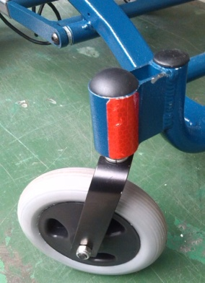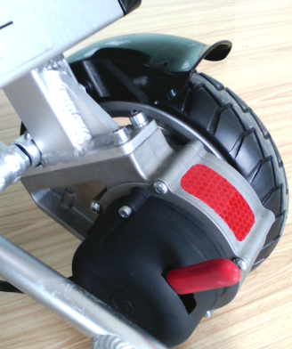

A3

1. When confronted with other vehicles, please ensure that the driver has noticed you. Before you continue to operate, make eye contact with the driver, and let the driver know your intention until you are sure that it is safe.

** Caution**

**The motorized vehicle safety**

**The Air Hawk halted state**

1. Don’t try to drive the Air Hawk on a bus or train you should be seated in a seat on that vehicle while in transit and not remain in the Air Hawk.

2. If you must drive Air Hawk on transportation means such as a cruise ship, you should be aware of all guidelines surrounding the people in charge.

3. When transporting the Air Hawk it should be tie down and secured to insure that it can not move while vehicle is in motion or in the event of sudden stop or traffic accident.

4. Don't place the Air Hawk in the front of other vehicles, so as not to interfere with the driver to drive.

5. When getting on or off, if you need to raise the user with the Air Hawk, please grip the edge of the seat frame, do not hold the handrail or back of chair to lift.

**Balance of driving**

**Caution**

**When using the Air Hawk you should maintain balance and stability. (center of gravity), in order to avoid tipping forward, backward and or sideways.**

The factors that influence the balance of the center of gravity are.

1. The height and angle of the seat.

2.The position and posture of the user's, or the change of weight distribution.

3.The ramp or slope gradient.

4. Whether use a backpack or other items to change the total weight of the Air Hawk and weight distribution.

5. If you need to modify or adjust the Air Hawk, please consult your suppliers in advance, and must have the authorization from the manufacture to do so. The modified unit, may need to be adjusted to correct the focus. Using a modified unit requires more caution until you are familiar with the balance of the unit, and master the method to avoid fall or tipping over.

**Attentions when up and down the stairs**



**Caution**

Never attempted to move a person up or down steps while in the Air Hawk. The Air Hawk should only be moved up or down steps when empty having no passenger.

**Avoid falling:**

When you are ready to seat in the Air Haw, you must turn off the power supply. Otherwise, if you touch the joystick, it may lead to the unexpected movement of Air Hawk.

Ensure that the motor is locked, and the Air Hawk won't move on its own.

Learn the safest way of moving the body from your professionals healthcare workers

Know how to locate your body, and how to support yourself in the process of transportation.

Let others help you, until you ensure that you can up and down the Air Hawk safely by yourself.

**B1**

1. Move your Air Hawk as close as possible to the place that you want to seat.

2. Rotate the front wheels that make them as front as possible.

3. Be careful of the pedal, and as far as possible to fold up(as shown in figureB1)

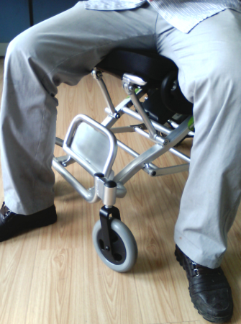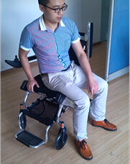

**B2**

• Don’t stand on the foot rest as it is dangerous and will damage the Air Hawk.

• Ensure your feet are not stumbled or nipped between the gap of the foot rest.

1. Ensure that you do not have any obstruction, interference of the armrest, fender.（B2）

5. You should transfer to the seat safely, it will reduce the risk of missing the seat or falling.

**Attentions when body tilt and stretch**

** Caution**

**Stretching out hand and body tilting will affect the center of gravity balance of the Air Hawk, if the operation method is not correct, may cause you to fall or tip over. The following several points is to reduce the risk of injury or damage to the Air Hawk.**

**1. If you must change your body’s center of gravity, including raise the body or leave the seat, please do not tilt your body out of the Air Hawk cushion.**

**2. If you have to move forward on your seat, please do not tilt too much(as shown in figure C1), need to keep your back in contact with your hip.**

**3. Don’t use your hand take distant objects reluctantly, In case of out of balance and fall.**

**4. Don’t try to pick up the goods between you knees or in front of your body in any cases.(as shown in figure C2)**

**5. When extend your body, please do not exert pressure, in case of Air Hawk overturned and cause serious hurt.**

**6. Don’t lean on the top of the seat back, to prevent falling and damaging the back of a chair.**

**7. If you must extend or tilt, you must take your own risk. Remember：**

1. Move your Air Hawk as close to the object you want to achieve.

2. Rotate front castor until they forward as much as possible.

**C2**

**C1**

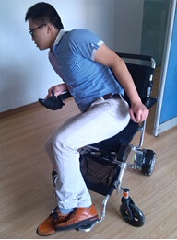 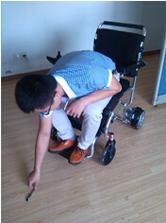

It will let the Air Hawk more stable.

**Attention:** when executing this operation, the range that you move has exceed your target, you need to back to close it, when it is going back, the front castor will rotate forward.

3.After you arrive, turning off the power of the Air Hawk.

**Dress in the Air Hawk**

**Caution**

**Attention**: when you sit in the Air Hawk always wear clothing, turn your body in order to make the Air Hawk more stable, you should adjust the rotating castor to the forward position.

**Through the obstacles**

** Caution**

You will need to overcome some obstacles in everyday use, including threshold, elevator, ramp, pits and broken pavement, etc.

1. Attention, threshold is very dangerous. Even a small height change maybe stuck the castor, and make the Air Hawk tilted and rollover.

• Dismantle the doorsill of the room or cover the doorsill and do not let the gradient become bigger.

• Install a door with a ramp.

2. When you move the Air Hawk, please look at the area carefully where you will go through.

3. Ensure that when you use this Air Hawk, you can go through the obstacles smoothly and safely.

4. You can adjust your center of gravity like this:

• When you are going through a obstacle, lean forward your upper body slightly.

• When you are going through a road which is from the high to the low, you should lean your upper body back.

**Driving back**

** Caution**

When you drive the Air Hawk back, you need to be careful. If the rear wheel hits an object, you may lose control or fall.

1. When driving, you should slow down.

2. Stop and check frequently, ensure that there isn’t any dangerous obstacle in the road you will go through.

**Cant/slope/hill driving**

** Caution**

On the slope, the balance of the gravity of your Air Hawk will change.

**Attention:** “slope” may be a ramp or hillside. If you are not sure the safety when the Air Hawk used on the slope, please use it under others’ help, do not use it alone.

**Attentions:**

1. When the gradient is more than 10°, please do not use it.

2. When on the slippery slope (such as snow, ice, water or oil), please do not use it.

3. When the slope is ups and downs (undulate, convex or concave), please do not use it.

4. If the bottom of the slope with small pits, please do not use it.

**Load capacity**

** Caution**

1. The maximum load of this Air Hawk is 120 kg (264 pounds), when using it, the load should not exceed the maximum bearing.

2. The backrest’s load is less than 75 kg, please do not press or raised up the back of the chair.

3. In any case, please don't do any weight testing in this kind of Air Hawk, even the total weight of the user’s and upraised weight is not more than the maximum bearing of the Air Hawk.

4. When the load capacity exceed the maximum bearing, it will damage the seat, frame, fasteners, folding, etc. Even may cause severe harm to the user or others, or make the Air Hawk damage to scrap.

5. Problems caused the load capacity exceeds the maximum bearing when using, we do not provide guarantee.

**Matters needing attention of up and down the stairs**

**Caution**

This Air Hawk is not suitable for travel, up and down the stairs, or on the escalator.

Pay attention to the following **cautions** when using the elevator.

·Do not use the escalator (elevator style) to move the Air Hawk, in order to avoid serious injury.

·The elevator can be used when you are sitting on the Air Hawk. Please push the Air Hawk after the elevator door opened, and ensure that when the Air Hawk getting into and out of the elevator, the elevator door is always open.

1. When the elevator is not available, if the Air Hawk is carried to the required place, need to expand, please refer to "shipping" section.

·Stair

Want to move the Air Hawk between floors by stairs, you should be in accordance with following specification to operate.

1. Remove the user from the Air Hawk.

2. Fold Air Hawk. Before folding, the joystick must be closed down. Refer to "shipping" section.

3. Move the Air Hawk when moving up and down the stairs, you should pay attention to avoid collision.

**Installation instruction**

**Safety belt installation**



**Caution**

The safety belt is optional and depends on the patient whether or not it is required. It is used to fix user’s body and prevent the user sliding from the seat. But it can’t protect you in the accident.

The safety belt can be adjusted according to the user’s comfort.

The safety belt is used to support the user, to prevent the user sliding forward.

Installation of the safety belt:

1.The user need to ensure that the safety belt had bind the waist and the bottom part of

Air Hawk backrest together.

2. Adjust the safety belt according to the user’s comfort.

2.1 After sitting down, please insert the plastic card to the other side of the plastic shell, until you hear a clicking sound.

2.2 Adjust the plastic safety belt to the appropriate length, do not over tighten which will cause discomfort.

Unfasten the safety belt:

Press the button of the plastic shell side, pull out the plastic card.

** Caution**

Before each use, ensure that the safety belt is fixed in the Air Hawk correctly and properly, and adjust to the most comfortable state of the user.

Before each use, check whether the safety belt is loose or damaged. If you find there is a problem, Please contact supplier to maintain and repair.

**Joystick installation instruction**

The control panel can be installed on the left or the right arm according to the users’ different requirement.

1. As shown in figure D1, insert the joystick to the armrest tube hole, and make sure it has been inserted in the right place, then fixed the joystick by knob lock.

2. As shown in figure of D2, aim at the socket, and insert the four-core plug into the left socket.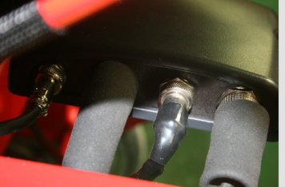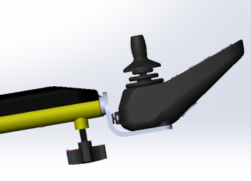

D1

D2

The control panel control to control Air Hawk. It consists of the following sections:

1. Switch on button:

Press this button, turn on and turn off the power of the Air Hawk.

2. Speed up button:

Press this button and speed up. The max speed is 6 km/h (3.75 miles per hour)

3.Slow down button:

Press this button, reduce the speed.

4.Horn button:

Press this button, the horn will ring.

5. Battery power indication light:

Show the battery power state.

6.Joystick:

The joystick control the direction and speed of the Air Hawk, push the joystick to the direction you want to go.

7. lamp button:

Press the little lights up, then shut down.

8.Speed/information diagnostic indicator light:

When the light is on, it means it does work , the light shows the meaning of display, there are 10 lights in total.

**Light flickers intermittently to provide diagnostic information. About the detail please refer to the following table:**

There are some diagnosis function, the diagnosis codes showed can reflect the property of problems.

|  |  |  |
| --- | --- | --- |
| **Diagnostic code** | **Diagnosis Description** | **Recommended solving methods** |
| Flicker one time slowly | Hall malfunction of left motor | Check the the welding situation of connection device of the left motor or check the internal hall component |
| Flicker two times slowly | Hall malfunction of right motor | Check the the welding situation of connection device of the right motor or check the internal hall component |
| Flicker three times slowly | Malfunction of battery or charger | Try to charge.  Maybe need to replace the battery or the charger.  Check if the battery or power wire is loose. |
|
| Flicker four times slowly | malfunction of left motor | Check the left motor, connection device and power wire is loose or not. |
| Flicker five times slowly | malfunction of right motor | Check the right motor, connection device and power wire is loose or not. |
| Flicker six times slowly | malfunction of left brake | Check the left brake, connection device and power wire is loose or not. |
| Flicker seven times slowly | malfunction of right brake | Check the right brake, connection device and power wire is loose or not. |
| Flicker eight times slowly | Malfunction of controller | Please contact the manufacturer |
| Flicker nine times slowly | Communication error | Check the electrical coupler ,connection and circuit is loose or not. |
| Flicker four times quickly | Over current of left motor | Releasing the rocker can eliminate the malfunction. |
| Flicker five times quickly | Over current of right motor | Releasing the rocker can eliminate the malfunction. |

**按下电源开/关按纽**

**Use the joystick to drive the Air Hawk**

**Caution**

When at highest speed, do not turn sharply.

If the user does not observe this warning, it may cause Air Hawk tilt, and may cause injury to the user.

The joystick, which is in the back of the control panel, can control the speed and direction smoothly. It is equipped with 360 - degree mobility and is easy to operate. There is spring in the joystick, so it can return to the center of the initial state automatically.

Push the joystick to the direction you want to go, Joystick has proportional control ability to drive, the greater range, the faster speed. The fastest speed is limited to 6 km/h (3.75 miles per hour).

If you want to slow down, just release the joystick. The Air Hawk will automatically slow down and correct direction in the minimum range.

When first using this Air Hawk, you should choose a slow speed to try, push the joystick forward slightly. This exercise will help you to learn how to control the Air Hawk, let you know and be familiar with how to control, and successfully master the methods of starting and stopping the Air Hawk.

Drive the Air Hawk, please do as the followings:

1.Adjust the control panel to the appropriate settings.

2.Turn on the power supply. Please refer to the previous section on "press the power on/off button".

3.Move the joystick as followings :

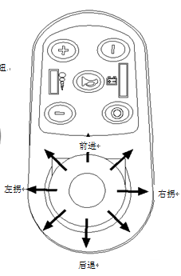

|  |  |
| --- | --- |
| Movement | Operate the joystick |
| Forward | Move the joystick forward |
| Backward | Move the joystick backward |
| Right | Move the joystick to the right |
| Left | Move the joystick to the left |
| Stop | Release the joystick (Air Hawk will slow down soon) |

**The use of the horn**

Press the horn button above the control panel, when crossing in the crowed, please use it.

Brake Instruction

** Caution**

After any adjustment, repair or maintenance or before using, please make sure all additional parts are screwed tightly , otherwise it may cause harm or damage.

Please do not open or close the electromagnetic brake when the power is on..

Through the operation of the joystick to open the electromagnetic brake (Refers to the electromagnetic brake, lock the free rolling of the wheels) or close (Refers to the electromagnetic brake is released, the wheels are free to roll), the escort can easily push the Air Hawk when power off.

**open**

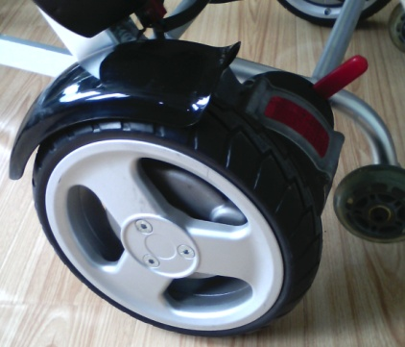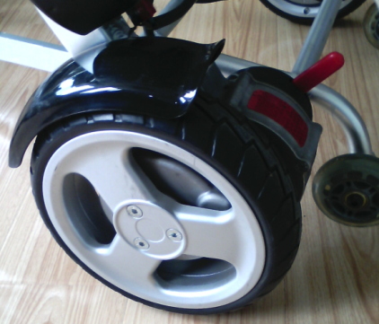

Electromagnetic

brake switch

**close**

**Close/open the electromagnetic brake**

Find the motor electromagnetic brake joystick and do the following operations:

Open the electromagnetic brake (lock) : push backward electromagnetic brake switch.

Close the electromagnetic brake (free) : push forward electromagnetic brake switch.

**Battery instruction**

Don't use the batteries with different capacity, different brands and different types. Replace the battery completely, don't mix up the old and new batteries.

 The metal or such kinds of this conductive materials can not be used to connect the positive and negative of the battery, if the connection lead to short circuit, it may get an electric shock causing some accidental damage.

 Don't close to flammable materials. Don't close to or exposed to the heat source, such as fires or sparks, etc. Don’t transport the battery with flammable or combustible materials together.



There are some corrosive chemicals in battery box,

disassembling the battery is prohibited.



Do not short circuit batteries or throw battery into the fire, so as to avoid

explosion accidents.

** Caution**

1. Don't try to use pliers or cable wire to connect the ends of battery directly.

2. Don’t use Air Hawk when it is charging.

3. Don't use non-standard power supply (for example: generator or inverter), even the voltage and frequency seams meeting the requirements.

4. To prevent the power wire trampled, extruded and serious bended, especially in the port. To prevent the power wire is yanked and knotted.

5. Keep the children and pets far away from the power wire, don't let them bite and chew it. When pull out the power wire, please hold the plug.

6. If the breaker (circuit insurance brake) tripped many times when charging, please unplug chargers immediately and contact the dealer or professional technical personnel.

7. In this guide, all the warranty and performance, ect are refer to lithium batteries.

8. Don't smoke or ignition near the battery.

9. It is forbidden to use battery in hot or cold environment.

 **Caution**

1. When first use the new battery, it must be fully charged (about 24 hours), make sure the battery is fully activated.

2. Before the first using, charging battery will reduce the life of the battery (The battery should be used up at the first time, then start charging, so it can be activated fully.)

3. Before using, the user should check if the power supply is enough or not, when the power is shortage, recharge in time. After the first time use, the charging time should be about 5 hours; When the power is run out, charging time should be 6 to 8 hours, until the light on the charger turns from red to green.

4. The recommended charging time is about 6 to 8 hours.

5. Charge the battery often, as long as the Air Hawk is used, Please charge the battery after using until it’s full. If you do not use the Air Hawk for a long time, please recharge it every 2 months, each time at about 80% of the electricity. It will damage the battery if there is no electricity for a long time, the battery will not be able to use, and it will damage the Air Hawk seriously.

6. If you use the battery with incorrect specification, voltage and capacity , it will

damage your Air Hawk, and the Air Hawk cannot play the best

performance and effect.

**Install/remove the battery**

** Caution**

Please make sure that this Air Hawk power has been shut down before performing this action.

**Take out the battery:**

Remove the red power plug (As shown in figure F1), then pull the battery handle (As shown in figure F2). Pull the battery from the battery tube.

**F1**

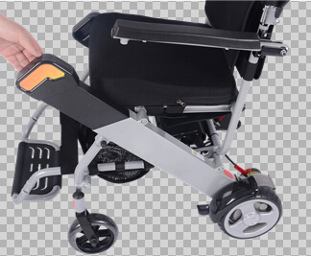

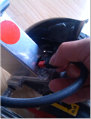

**F2**

**G1**

G1

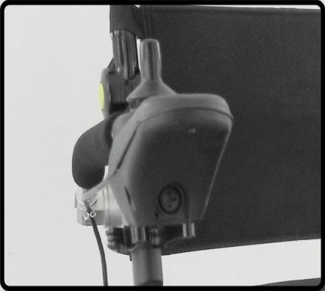**Install the battery:**

Hold the battery handle, insert the other side of the battery into the right side mouth of the battery tube to the end, then insert the red power plug into the bottom hole of the battery tube.

**Charge the battery**

1. Use available standard alternating current (AC 110-220 V, 50-60 Hz) for charging, the charging mouth is in front of the control panel below.

2. Make sure that the power is off before charging .

3. Insert the charging port of the charger into the charging port in front of the control panel below.(As shown in figure G1)

4. Insert the other side of the charger into socket. If the red indicator is light, it shows it’s charging.

5. After the charger indicator light change from red to green, then keep charging for 30 minutes, so as to ensure the full charge. Unplug the external power supply socket of the charger first, then unplug the socket of the control panel.

6. It is forbidden to use the battery in the hot or cold environment.

**Over discharge protection device**

When the battery of the Air Hawk is run out, the over discharge protection device will protect the charger for excessive discharge. Users should pay attention to, when the over discharge protection device is activated, the maximum speed will reduce.

**Over-current protection device**

The Air Hawk is also equipped with a over-current protection device. If the current provided to the motor is over, the electronic fuse will close the current.

If encountered with some malfunction when driving, the over-current protection device will be started, the driving wheels will stop rotating. In this process, the fuse will cut off the current, prevent the motor being damaged by overheating.(See the control panel section)

**Clean the battery socket**

** Caution**

1. Check whether the battery case and the positive and negative of the battery is corroded or not.

2. Check whether the plastic battery box has been assembled completely.

3. Use battery cleaning tools, medium sandpaper to clean battery port.

**Attention:** after finish cleaning, the above parts should be light and dry.

4. Clean up all the dust of the metal particles carefully.

5. Don't touch the battery materials with the skin, clothing or other property. It

is a kind of acidic material, and may lead to harmful or destructive burns. If you touched

The materials, please immediately wash your skin thoroughly with cold water.

If it’s serious or your eyes touched it, please see the doctor immediately.

**Fold and unfold**

**Caution**

After any adjustment, repair or maintenance, please ensure that all additional parts are screwed tightly, otherwise it may cause harm or damage.

The weight of the unit is 37 Ib, please use the right way to lift (lift with your legs) not your back to avoid injury. Never lift the Air Hawk while occupied. Remove the user first then lift the Air Hawk.

**Electric Air Hawk folding method**

**Step:**

1. Shut off the power, loose the lever lock knob, remove it from the control panel and put it in the back

of the chair pad.

2. Rotate both sides of the PU to seat level.

3. Take down the seat cushion.

4. Pull steel wire under the backrest.

5. Push the backrest forward to the tube of all-direction wheel (need pushed in the right place).

6. lift the connecting rod by hand to be parallel with the support bar and the back of motor frame.

7. The Air Hawk folding is completed.

**This process, please refer to the blew:**

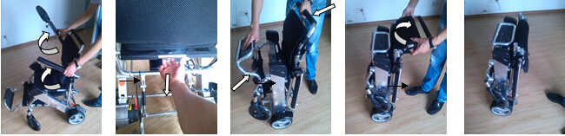

**Unfold the electric Air Hawk**

**Step:**

1. One hand holds the Air Hawk backrest frame, the other hand grabs at the battery

tube to the outside, and at the same time presses the connecting rod to the largest extent, open

the back parts of the electric Air Hawk. (when you press the connecting rod group, make sure

that fixed card in stuck range)

2. Push the backrest back to the largest extent, at the same time, make sure that if the wire is bounced to the hole location of the backrest frame. ( Before use the Air Hawk, the user must make sure that the thread locking pin had bounced the fixed hole location, otherwise, it can cause harm to user)

3. Install the seat cushion and make sure that the felt has aligned and mated.

4. Adjust the PU to the appropriate angle.

5. Install the control panel (see the page of install control panel)

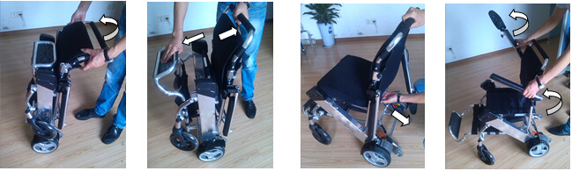

**Malfunction and eliminating methods**

There is a diagnostic indicator in the control panel. When the light is green, it means this Air Hawk has no problem. When there is something wrong with it, it will report by flickering.

If the indicator light indicators there is something wrong, the user should turn off the power and then open it again.

If after opening again, the malfunction is not eliminated and the light repeats this error, please refer to the diagnosis information, it can help you find the possible problems and corresponding solutions.

If the above methods still can’t help you troubleshoot, please contact the dealer.

**※ The diagnosis system**

**1. Introduction**

When maintenance LED light flickers, it means that there is something wrong with the Air Hawk. And the alarm may generate from motor, brake,

battery, wire connection, or the Air Hawk itself. The property of the problems can be classified according to the diagnosis code. According to the times the LED light flickers, pauses, flickers several times again repeatedly. This times that flickered are the diagnosis code. For example, the LED light flickers four times, pause, and flickers four times again, such repeatedly, it means that there is something wrong with the light motor. If it’s five times, it means there is something wrong with the right motor.

According to the situation is serious or not, the Air Hawk may stop working. Under some situation, the Air Hawk is not allowed to used.

1. **Flashing code**

|  |  |  |
| --- | --- | --- |
| **Diagnostic code** | **Diagnosis Description** | **Recommended solving methods** |
| Flicker one time slowly | Hall malfunction of left motor | Check the the welding situation of connection device of the left motor or check the internal hall component |
| Flicker two times slowly | Hall malfunction of right motor | Check the the welding situation of connection device of the right motor or check the internal hall component |
| Flicker three times slowly | Malfunction of battery or charger | Try to charge.  Maybe need to replace the battery or the charger.  Check if the battery or power wire is loose. |
|
| Flicker four times slowly | malfunction of left motor | Check the left motor, connection device and power wire is loose or not. |
| Flicker five times slowly | malfunction of right motor | Check the right motor, connection device and power wire is loose or not. |
| Flicker six times slowly | malfunction of left brake | Check the left brake, connection device and power wire is loose or not. |
| Flicker seven times slowly | malfunction of right brake | Check the right brake, connection device and power wire is loose or not. |
| Flicker eight times slowly | Malfunction of controller | Please contact the manufacturer |
| Flicker nine times slowly | Communication error | Check the electrical coupler ,connection and circuit is loose or not. |
| Flicker four times quickly | Over current of left motor | Releasing the rocker can eliminate the malfunction. |
| Flicker five times quickly | Over current of right motor | Releasing the rocker can eliminate the malfunction. |

**The warranty instruction**

**The warranty scope**

The warranty instruction:

|  |  |  |
| --- | --- | --- |
| Guarantee Item | Guarantee period for free | Remark |
| Main frame | Four years | Malfunction caused by improper use, man-made destruction or secret conversion, there is no guarantee ,or we need charge the maintenance fee. |
| Motor wheel | The warranty of reducer and PU tires is one year, others are three years. | Excess load lead to motor overload or opened without permission lead to damage, no guarantee. |
| Battery | Two years | Recharge in wrong way, and disconnect the battery without permission cause damage, no guarantee. The company is not responsible for an accident. |
| Controller | One year | Malfunction caused by improper use, man-made destruction or secret conversion, there is no guarantee ,or we need charge the maintenance fee. |
| Joystick | One year | Malfunction caused by improper use, man-made destruction or secret conversion, there is no guarantee ,or we need charge the maintenance fee. |

保修期内故障维修时需持有购买发票及保修卡，无保修凭证本公司维修需收费。过保修期维修收取材料费，运输费客户承担。

**※ The scope of the no guarantee:**

1. No guarantee:

a) Back cushion, seat cushion, armrest foam cotton, backrest foam cotton, decorating parts are damaged after use.

b) Damage caused by mal-operation, accident, abuse, improper installation and repair.

c) Damage caused by refitting the product without the written consent of the manufacturer

d) Damage caused by the load capacity exceeding.

1. If the serial number of the Air Hawk is not the original serial number, having been

modified or not match with the serial number of the guarantee card, or the serial number of the guarantee card has been revised, no guarantee.

3. This warranty card is non-transferable and only for the use of Air Hawk buyers.

Within the permissible scope of the law, this warranty will take the place of any other warranty guarantee (e.g., written or oral, express or implied warranty, including merchantability, or suitability for a particular purpose guarantee), are all based on this warranty.

**Guarantee card**

The guarantee card must be handed over to the after-sales department of the manufacturer

in 15 days after returned to the dealer.

|  |  |  |  |
| --- | --- | --- | --- |
| The user name |  | ID number |  |
| Address |  | Contact number |  |
| Model |  | Product number |  |
| Purchasing date | | Month Day Year | |
| Manufacturer | |  | |
| Supplier (Stamp or signature) | |  | |
| Supplier phone( address) | |  | |

1. The guarantee statement:

The supply dealer should confirm the problems of Air Hawk first. Under the condition of using incorrect

way, if it is the quality problem, the dealer need to fix or change the parts.

2. No guarantee:

1) Incorrect operation and maintenance

2) Using incompatible replacement part3) Accident or misuse caused by mechanical damage

4) Consumable items are not in the warranty scope, such as tire, bearing, bulb, etc.

5) Any unauthorized conversion.

6) Any questions caused by natural disasters or accidents, such as typhoon, flood and earthquake. This quality warranty does not include the routine maintenance or detection service.

7) This quality warranty does not include the routine maintenance or detection service.

8) This warranty only applied to the original Air Hawk bought from us, not allowing any transfer.

**Guarantee card**

The guarantee card must be handed over to the after-sales department of the manufacturer

in 15 days after returned to the dealer.

|  |  |  |  |
| --- | --- | --- | --- |
| The user name |  | ID number |  |
| Address |  | Contact number |  |
| Model |  | Product number |  |
| Purchasing date | | Month Day Year | |
| Manufacturer | |  | |
| Supplier (Stamp or signature) | |  | |
| Supplier phone( address) | |  | |

1. The guarantee statement:

The supply dealer should confirm the problems of Air Hawk first. Under the condition of using incorrect

way, if it is the quality problem, the dealer need to fix or change the parts.

2. No guarantee:

1) Incorrect operation and maintenance

2) Using incompatible replacement part3) Accident or misuse caused by mechanical damage

4) Consumable items are not in the warranty scope, such as tire, bearing, bulb, etc.

5) Any unauthorized conversion.

6) Any questions caused by natural disasters or accidents, such as typhoon, flood and earthquake. This quality warranty does not include the routine maintenance or detection service.

7) This quality warranty does not include the routine maintenance or detection service.

8) This warranty only applied to the original Air Hawk bought from us, not allowing any transfer.

**Contact:  
Discover Your Mobility Inc.  
66 E Ten Mile Rd  
Hazel Park Mi. 48030**